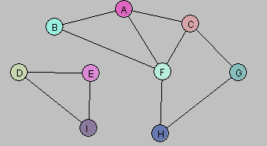**Problem 1**

a. Let U = {A, B}. Draw G[U].

C:\Users\huynh\Desktop\Problem 1 a.png

b. Let W = {A, C, G, F}. Draw G[W].

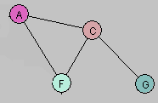

c. Let Y = {A, B, D, E}. Draw G[Y].

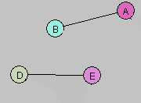

d. Consider the following subgraph H of G:

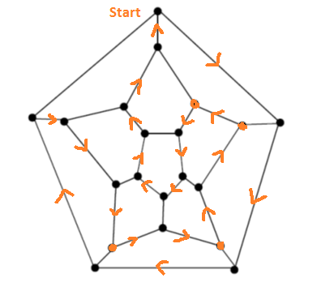**Problem 3**